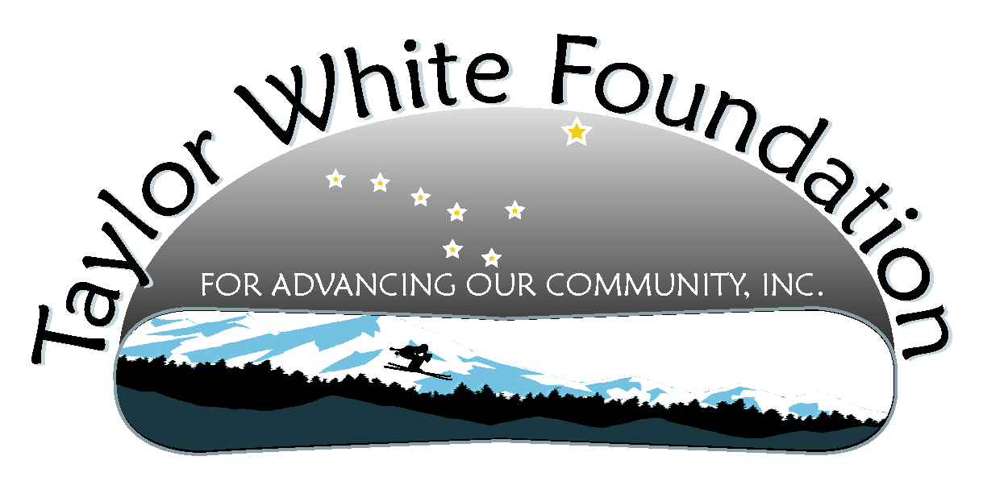
Taylor White Foundation Board Meeting
October 14, 2012

Minutes

Present: Loree DiCarlo, Justine Muench, Carol White, Sam Roche, Morgan Thomas, Linda Cabello, Darby Brown, Zach Gray, Kendra Buerger

Rather than a formal agenda the group went through the Driver’s Training project plan and assigned follow up items to people. They are as follows:

Task | Person Responsible | Due Date
Check with John Pugh about the use of the pavilion | Justine | November 11
Be sure John Pugh knows we are hoping for a 2 day training both Sat and Sun April 13-14 | Justine | November 11
Getting certificate of insurance from UAS Facilities director to Matt Reilly | Carol | January 2013
See if use of a water truck could be donated | Zach | November 11
See if use of 400 traffic cones could be donated | Zach | November 11
See if use of a baseball lining machine could be donated | Zach | November 11
Exploring free airline tickets from AK Airline | Carol, Linda, Darby | November 11
Looking into lodging for instructors | Darby – UAS dorms  Kendra – hotels  Linda – Grandma’s and Best Western | Jan 2013
Looking into cars for the event | Carol | November 11
Developing a sponsorship form | Darby and Kendra | November 11
Writing grants | Carol and Sam | October 31
Getting instructors that can be trained | Carol | November 11
Exploring best place to get a banner and pricing | Loree | November 11
Exploring getting a Foundation key fob for participants | Loree | November 11
Developing a website dedicated to the training | Morgan | Jan 2013
Exploring an artist to do a print as a fund raiser | Justine | November 11
Explore food donations (suggested El Sombrero, Superbear, and Costco) | Linda, Loree, Darby | February 2013

The next meeting is Sunday, November 11, and will be the first meeting with Carol on the road! The call in number is 888-808-6929 code: 2757809. Those in Juneau may decide to congregate at someone’s home. Please let me know and I will send out an email, or you can just hit reply all and send it instead.

